OMAN, 25.11. – 01.12.2015
Participanti : Simó Imre, Bodó Attila
Deplasarea, cazarea
Am zburat pe ruta Bucurest-Dubai, Al Mactoum -Bucuresti, pretul biletelor era 420 euro dus –intors/persoana. La aeroport am inchiriat o masina un Ford Focus 1,6 automat cu pretul de22 euro/zi. Erau masini si mai ieftine, incepand de la 17 euro/zi dar numai la aceasta comapanie (National) era fara limita de km respectiv ei ne lasau sa ne deplasam in Oman fara suprataxa. Se poate inchiria si masini de teren la un pret dublu sau triplu, dar noi ne am descurcat si cu asta lejer. Pretul benzinei era 1,35 lei/litrul –nu este scris gresit-. Drumurile sunt foarte bune, fara gropi cu mai multe benzi, in general au o infrastrucuta foarte buna, nu sunt multe localitati, orasele se concentreaza mai ales pe zona de coasta. In jurul oraselor mari este plin cu radare fixe viteza maxima este de 120km/ora. Ca forma de cazare am ales cortul, in Oman este permis camparea cu cortul, o singura zi am ales un hotel in oazal Quitbit ca sa ne spalam si pentru ca in jurul hotelului este un parc cu copaci care atrage pasarile , in fine aici am platit 20 de Rial adica 20*10,8 lei pe camera. La receptie este un caiet unde pasarari trec observatiile care realmente pot fi de mare folos. Oaza este destul de buna in timp de migratie dar este destul de aglomerat, aici sunt cazati cateva sute de muncitori. Noi am mancat pe strada, Oman este plin de mincaruri tip fast food. Noi am preferat localurile frecventate de indieni, pachistanezi, bangladeseni si arabi aici se poate manca chiar din 15-20 lei de 2 ori pe zi, carnea si pestele sunt scumpe.
Determinatoare
Am folosit cartea Birdwatching in Omand 2nd Edition, o lucrare buna singurul lipsa este ca a fost publicat in 2008 si de atunci sa sa construit mult in Oman au aparut drumuri si autostrazi noi cea ce complica putin orientarea. Determinatoare: Collins Bird Guide 2nd Edition ( Lars Svenson and co), Helm field guides: Birds of the Middle East( Richard Porter, Simon Aspinal and co) eceasta nici pe departe atit de complex si bun ca Collinsul dar mai adecvat locului.
De ce Oman? Recomandari personale
Locurile sunt usor accesibile cu multe pasari, oameni sunt foatre amabili si curiosi, eram invitati la mancare frecvent de localnici arabi. Pentru cei car nu vor sa viziteze de mai multe ori Omanul le recomand o vizita de 10-12 zile in perioada de migratie la inceputul luni noiembrie, de luat in seama este si o tura pe mare pentru specii pelagice, acici se poate vedea cel putin10 specii pe care noi nu am vazut. In criza de timp puteti neglija zonele de nord de Muscat, noi am revazut toate specile la Sannanah Beach si Flim cu exceptia Xenus cinereus.
Specii de top sunt: Masked Boby ( Sula dactylatra), Abdim Stork (Ciconia abdimii), Crested Honey Buzzard (Pernis ptilorhynchus), Verreaux’s Eagle (Aquila verreauxii), White-breasted Waterhen (Amaurornis phoenicurus), Sociable Lapwing( Vanellus gregarious), Great Knot ( Calidris tenuirostris), Oman Owl, Dhofar Swift, Collared Kingfisher( Todirhamphus chloris), Crab Plover (Ardeola dormas), Hypocolius( Hypocolius ampelinus), Bar-tailed Lark (Ammomanes cincturus), Oriental White Eye (Zosterops palpebrosus), Black-throated Trush(Turdus atrogularis), Red-throated Trush(Turdus ruficollis), Yemen Serine( Crithagra menachensis), Arabian Golden-winged Grosbeak (Rhynchostruthus percivali) si altele.
Locurile vizitate:
Liwa, multe limicole: Greater Sand Plover -Charadrius leschenaultii, Lesser Sand Plover -Charadrius mongolus, Crab Plover- Ardeola dormas, Terek Sandpipier –Xenus Cinereus erau destul de commune
Sohar : aici ne am oprit la un farm agricol irigat si am vazut: Daurian Shrike-Lanius isabellinus, Indian Roller -Coracias bengalensis, Watled Lapwing- Vanellus indicus, Green Bee-eater- Merops orientalis cynophrys, Graceful Prinia-Prinia gracilis
Qurayyat: Greater-spoted Eagle, Sooty Gull-Larus hemprichii cel mai comun paecarus impeuna cu fuscus si genei, Grey Francolin-Francolinus pondicerianus, Swift Tern-Sterna bergii, Bonelli’s Eagle- Aquila fasciatus
Shannah beach: pe departe cel mai bun loc pentru limicole- cel putin pentru mine- unde am fost vreodata, ma ducea aminte de Istria pe vremuri cand era sarat. Locul este mare si in timp de reflux plin-plin pasari ca Crab Plover-Ardeola dormas, Limosa laponica specie cea mai numeroasa pe zona respective toate speciile de fugaci si fluierari intalnite si la noi, Socotra Cormorant-Phalacrocorax nigrogularis, Pluvialis squatarola, Pluvialis fulva, Striated Heron-Butorides striata, Baltic Gull- Larus fuscus,- graelsi si -intermidius. Locul este bun si pentru Great Knot- Calidris tenuirostris pe care noi nu am reusit sa vedem.
Muntasar: o oaza mica nepopulata langa care era o ferma de camile si deranjul era foarte mare, Attila zice ca acum doi ani era o miscare foarte buna Acum era destul de slab probabil migratia se sfarsise deja sau deranjul era prea mare. Speciile erau: Rufous Turtle Dove-Streptopelia orientalis meena, Arabian Scops Owl- Otus pameale, Steppe Grey Shrike- Lanius palidiostris, Southern Grey Shrike- Lanius meridionalis, Desert Warbler –Sylvia nana, Philoscopus colybita tristis
Quatbit: un habitat foatre deranjat plin cu pisici si muncitori, un parc cu copacii linga hotelul unde ne am cazat, Asian Koel-Eudynamys scolopaceus, Booted Warbler-Iduna calygata
Al Albeen farm: o plantatie de pepeni aproximativ 200-300 de ha intre Ouatbit si Thumrait. O zona foarte buna pentru cocarlii si gainusele de stepa. Am reusit sa observam :Burhinus oedicnemus, Cream –coloured Cursor - Cursorius cursor, Spotted Sandgrouse -Pterocles senegalensis, Crowned Sandgrouse Pterocles coronatus, Bar-tailed Lark-Ammomanes cinctures, Desert Lark-Ammomanes deserti, Calandrella brachydactyla, Hoopoe Lark- Alaemon alaudipes, Black-crowned Sparrow Lark- Eremopterix nigriceps
Thumrait, rampa de gunoi, un loc bun pentru acvile care se lasa observati de la o distant relative mica, noi am vazut in jur de 35-40 de exemplare majoritatea Aquila nipalensis de mai multe varste si cateva Aquila clanga
Wadi Razat, aproape de Salalah: Striolated Bunting-Emberiza Striolata, Rupel’s Weaver-Ploceus galbula, Palestine Sunbird-Cinniris osea, Monticola Solitarius, Hooded Warbler-Oenanthe monaca, Blackstart-Cercomela melanura, Tristram’s Starling, Onycognathus tristramii, Abesinian White Eye- Zooterops abisinicus, Arabian Warbler -Sylvia leucomelanea, Black-crowned Tsagra-Tchagra senegalus, Buce Green Pigeon-Treron Waalia, Arabian Partrige-Alectoris melanochephala
Speciile observate:
nr | DENUMIREA ROMANA | DENUMIREA LATINA | DENUMIREA ENGLEZA
 |  | Alectoris melanocephala | Arabian Partridge
 |  | Ammoperdix heyi | Sand Partridge
 |  | Francolinus pondicerianus | Grey Frankolin
 | Rata mare | Anas platyrhynchos | Mallard
 | Rata lingurar | Anas clypeata | Shoveller
 | Corcodel cu gat negru | Podiceps nigricollis | Black-necked Grebe
 |  | Phoenicopterus roseus | Greater Flamingo
 | Lopatar | Platalea leucorodia | Spoonbill
 |  | Butorides striata | Striated Heron
 | Starc cenusiu | Ardea cinerea | Grey Heron
 | Starc de noapte | Nycticorax nycticorax | Night Heron
 | Egreta mare | Egretta alba | Great Egret
 |  | Egretta intermedia | Intermediate Egret
 | Egreta mica | Egretta garzetta | Little Egret
 |  | Egretta gularis | Reef Heron
 | Cormoran mare | Phalacrocorax carbo | Great Cormorant
 |  | Phalacrocorax nigrogularis | Socotra Cormorant
 | Uligan pescar | Pandion heliaetus | Osprey
 |  | Torgos tracheliotus | Lapped-faced Vulture
 | Hoitar | Neophron percnopterus | Egyptian Vulture
 | Erete de stuf | Circus aeruginosus | Mars Harrier
 | Erete | Circus macrourus | Pallid Harrier
 | Uliu pasarar | Accipiter nisus | Sparrowhawk
 |  | Buteo buteo vulpinus | Steppe Buzzard
 | Acvila tipatoare mare | Aquila clanga | Greater Spotted Eagle
 | Acvila de stepa | Aquila nipalensis | Steppe Eagle
 |  | Aquila fasciatus | Bonelli’s Eagle
 | Vanturel rosu | Falco tinnunculus | Kestrel
 |  | Rallus aquaticus | Water Rail
 |  | Burhinus oedicnemus | Stone -curlew
 |  | Cursorius cursor | Cream –coloured Courser
 |  | Haemantopus ostralegus | Oystercatcher
 |  | Dromas Ardeola | Crab Plover
 |  | Himantopus himantopus | Black-winged Stilt
 |  | Vanellus indicus | Red-wattled lapwing
 |  | Pluvialis squatarola | Grey Plover
 |  | Pluvialis fulva | Pacific Golden Plover
 |  | Charadrius dubius | Little Ringed Plover
 |  | Charadrius alexandrinus | Kentish Plover
 |  | Charadrius mongolus | Lesser Sand Plover
 |  | Charadrius leschenaultii | Greater Sand Plover
 |  | Limosa limosa | Black-tailed Godwit
 |  | Limosa laponica | Bar-tailed Godwit
 |  | Numenius phaeous | Whimbrel
 |  | Numenius arquata | Curlew
 |  | Tringa erythropus | Spotted Redshank
 |  | Tringa totanus | Common Redshank
 |  | Tringa nebularia | Greenshank
 |  | Tringa ochropus | Green Sandpiper
 |  | Tringa glareola | Wood Sandpiper
 |  | Xenus cinereus | Terek Sandpipier
 |  | Actitis hypoleuca | Common Sandpiper
 |  | Calidris minuta | Little Stint
 |  | Calidris temminckii | Temminck’ s Stint
 |  | Calidris alba | Sanderling
 |  | Calidris ferruginea | Curlew Sandpiper
 |  | Calidris alpina | Dunlin
 | Bataus | Philomachus pugnax | Ruff
 |  | Arenaria interpres | Turnstone
 |  | Larus hemprichii | Sooty Gul
 |  | Larus canus | Common Gul
 |  | Chroicocephalus ridibundus | Black-headed Gull
 |  | Chroicocephalus genei | Slender-billed Gull
 |  | Larus marinus | Great Black-backed Gull
 |  | Larus cachinnans | Caspian Gull
 |  | Larus heuglini | Heuglin’s Gull
 |  | Larus barabensis | Steppe Gull
 |  | Larus fuscus | Baltic Gull
 |  | Gelochelidon nilotica | Gull-billed Gull
 |  | Hydroprogne caspia | Caspian Tern
 |  | Sterna bengalensis | Lesser Crested Tern
 |  | Sterna bergii | Swift Tern
 |  | Sterna sandwichensis | Sandwich Tren
 |  | Sternula albifrons | Little Tern
 |  | Chlidonias hybrida | Whiskered Tern
 |  | Pterocles exutus | Chesnut-bellied Sandgrouse
 |  | Pterocles senegallus | Spotted Sandgrouse
 |  | Pterocles coronatus | Crowned Sandgrouse
 |  | Columba livia | Rock Dove
 |  | Treron waalia | Bruce’s Green Pigeon
 |  | Streptopelia turtur | Turtle Dove
 |  | Streptopelia meena | Rufous Turtle Dove
 |  | Streptopelia decaocto | Collared Dove
 |  | Spilopelia senegalensis | Laughing Dove
 |  | Psittacula krameri | Rose-ringed Parakeet
 |  | Eudynamys scolopaceus | Asian Koel
 |  | Otus pamale | Arabian Scops Owl
 |  | Coracias bengalensis | Indian Roller
 |  | Upupe epops | Hoopoe
 |  | Alcedo athis | Kingfisher
 |  | Merops orientalis cynophrys | Green Bee-eater
 |  | Tchagra senegalus | Black-crowned Tchagra
 |  | Lanius collurio | Red-backed Shrike
 |  | Lanius isabellinus | Daurian Shrike
 |  | Lanius palidirostris | Steppe Grey Shrike
 |  | Lanius meridionalis | Southern Grey Shrike
 |  | Corvus splendens | House Crow
 |  | Corvus ruficollis | Brown-necked Raven
 |  | Pycnonotus leucotis | White-eared Bulbul
 |  | Pycnonotus xanthopygos | White-spectacled Bulbul
 |  | Eremopterix nigriceps | Black-crowned Sparrow Lark
 |  | Alaemo alaudipes | Greater Hoopoe Lark
 |  | Galerida cristata | Crested Lark
 |  | Calandrella brachydactyla | Greater Short-toed Lark
 |  | Ammomanes deserti | Desert Lark
 |  | Ammomanes cincturus | Bar-tailed Lark
 |  | Ptyonoprogne obsoleta | Pale Crag Martin
 |  | Prinia gracilis | Graceful Prinia
 |  | Iduna caligata | Booted Warbler
 |  | Phylloscopus trochilus | Willow Warbler
 |  | Phylloscopus collybita tristis | Chiffchaff
 |  | Sylvia leucomelaena | Arabian Warbler
 |  | Sylvia nana | Asian Desert Warbler
 |  | Sylvia curruca | Lesser Whitethroat
 |  | Sylvia minula | Desert Whitethroat
 |  | Zosterops abyssinicus | Abyssinian White-eye
 |  | Acridotheres tristis | Common Myna
 |  | Sturnus vulgaris | Common Starling
 |  | Onychognathus tristramii | Tristram’s Starling
 |  | Luscinia svecica | Bluethroat
 |  | Phoenicurus ochruros semirufus | Black Redstart
 |  | Phoenicurus phoenicurus | Common Redstart
 |  | Saxicola rubetra | Whinchat
 |  | Oenanthe isabellina | Isabelline Wheatear
 |  | Cercomela melanura | Blackstart
 |  | Oenanthe deserti | Desert Wheatear
 |  | Oenanthe chrysopygia | Red-tailed Wheatear
 |  | Oenanthe albonigra | Hume’s Wheatear
 |  | Oenanthe monacha | Hooded Wheatear
 |  | Monticola solitarius | Blue Rock Trush
 |  | Ficedula parva | Red-breasted Flycatcher
 |  | Cinnirys osea | Palestine Sunbird
 |  | Cinnirys asiaticus | Purple Sunbird
 |  | Passer domesticus | House Sparrow
 |  | Ploceus galbula | Ruppell’s Weaver
 |  | Motacilla alba | White Wagtail
 |  | Motacilla flava | Yellow Wagtail
 |  | Motacilla cinerea | Grey Wagtail
 |  | Anthus campestris | Tawny Pipit
 |  | Anthus spinoletta | Water Pipit
 |  | Anthus cervinus | Red-throated Pipit
 |  | Emberiza striolata | Striolated Bunting
 |  | Miliaria calandra | Corn Bunting

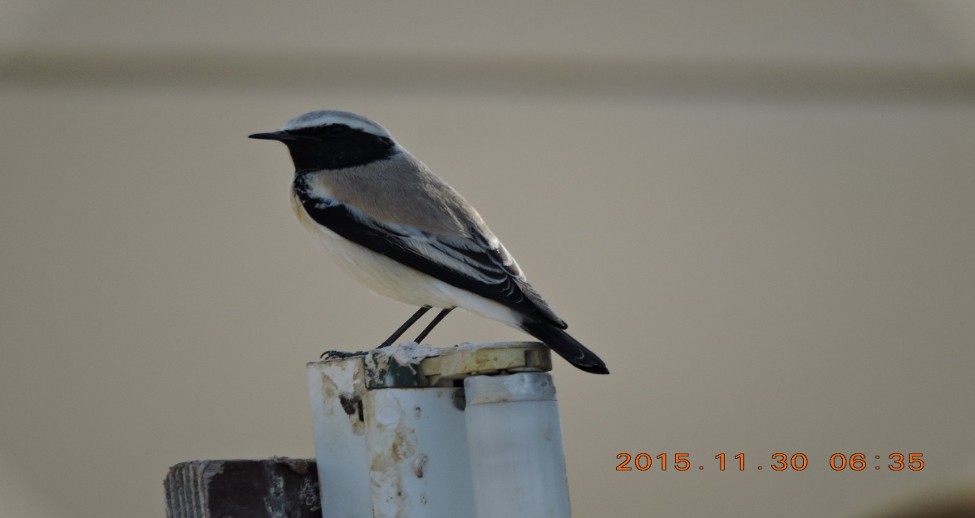
Simo Imre: Desert Wheatear- Desert wheatear, Quatbit
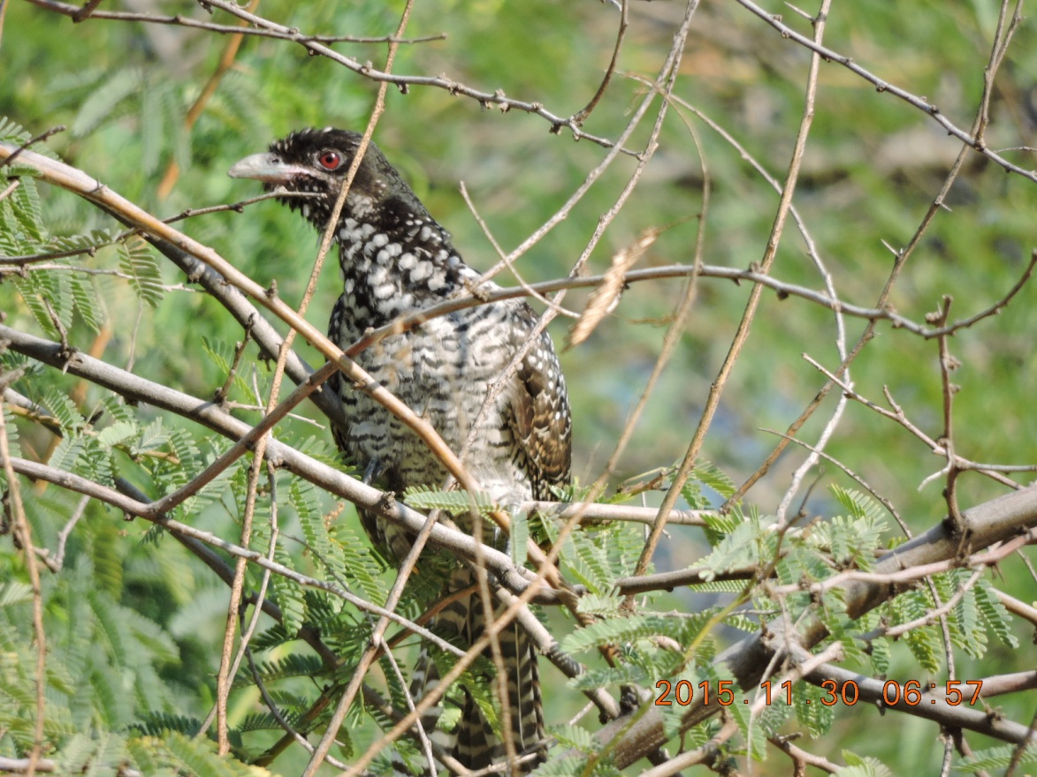
Simó Imre: Koel- Eudynamys scolopaceus, femela, Quatbit
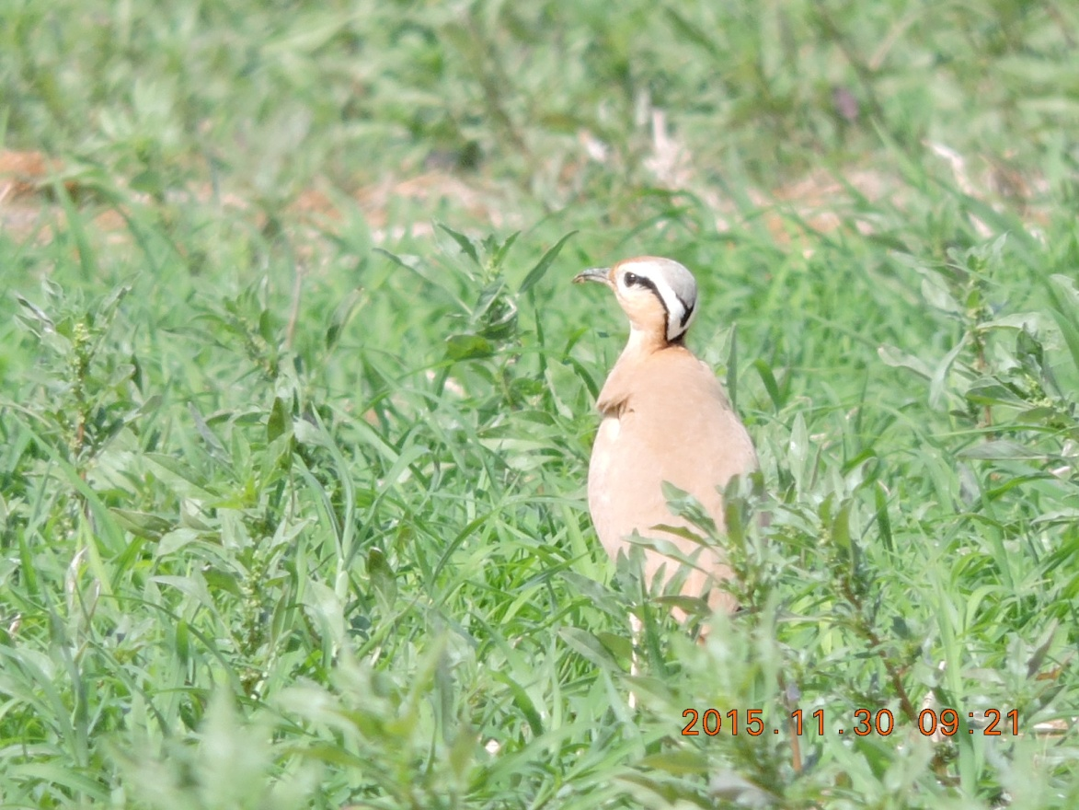
Bodó Attila : Cream –coloured Courser-Cursorius cursor, ferma Albeen
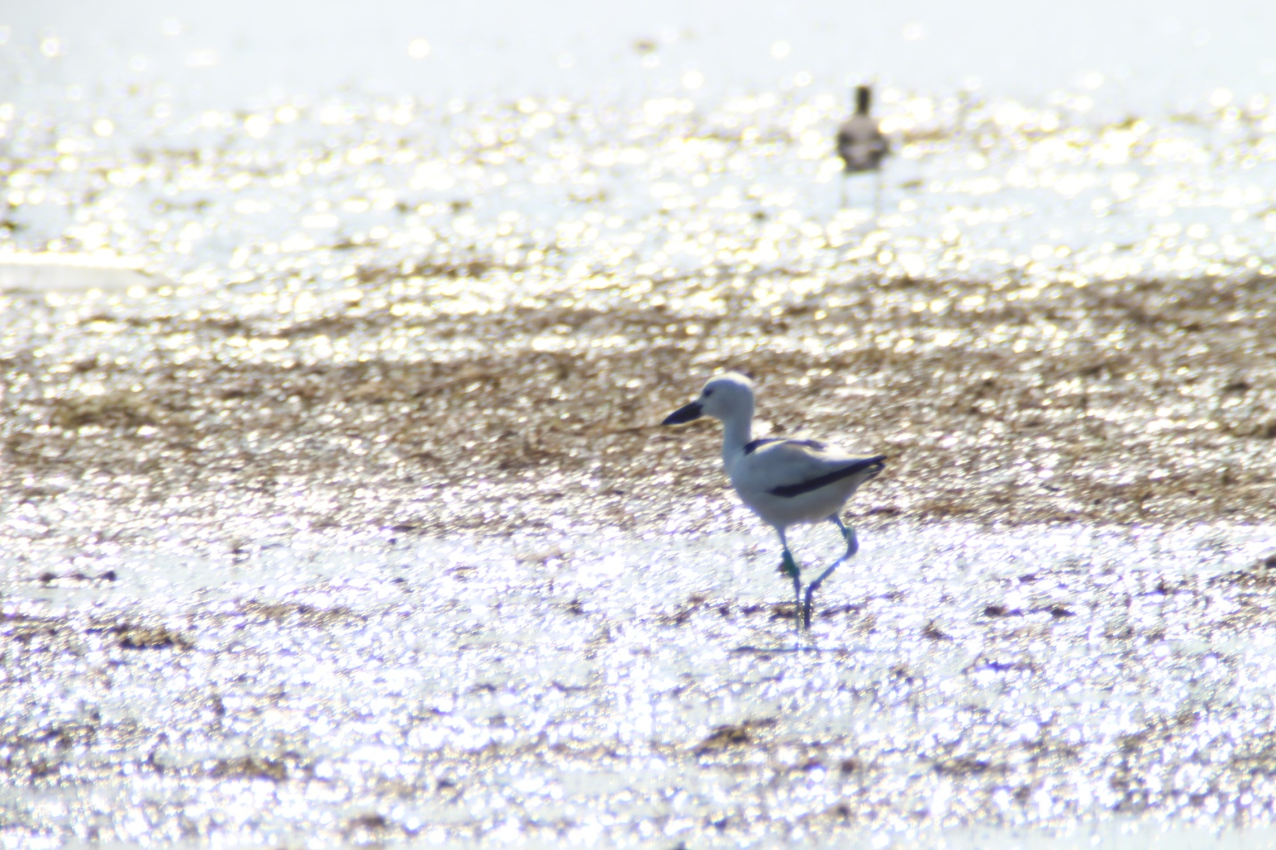
Bodó Attila : Crab plover Ardeola dormas , exemplar inelat in anul 2011 de Roeland Bom la Barr al Hikman-aproape de unde am vazut noi
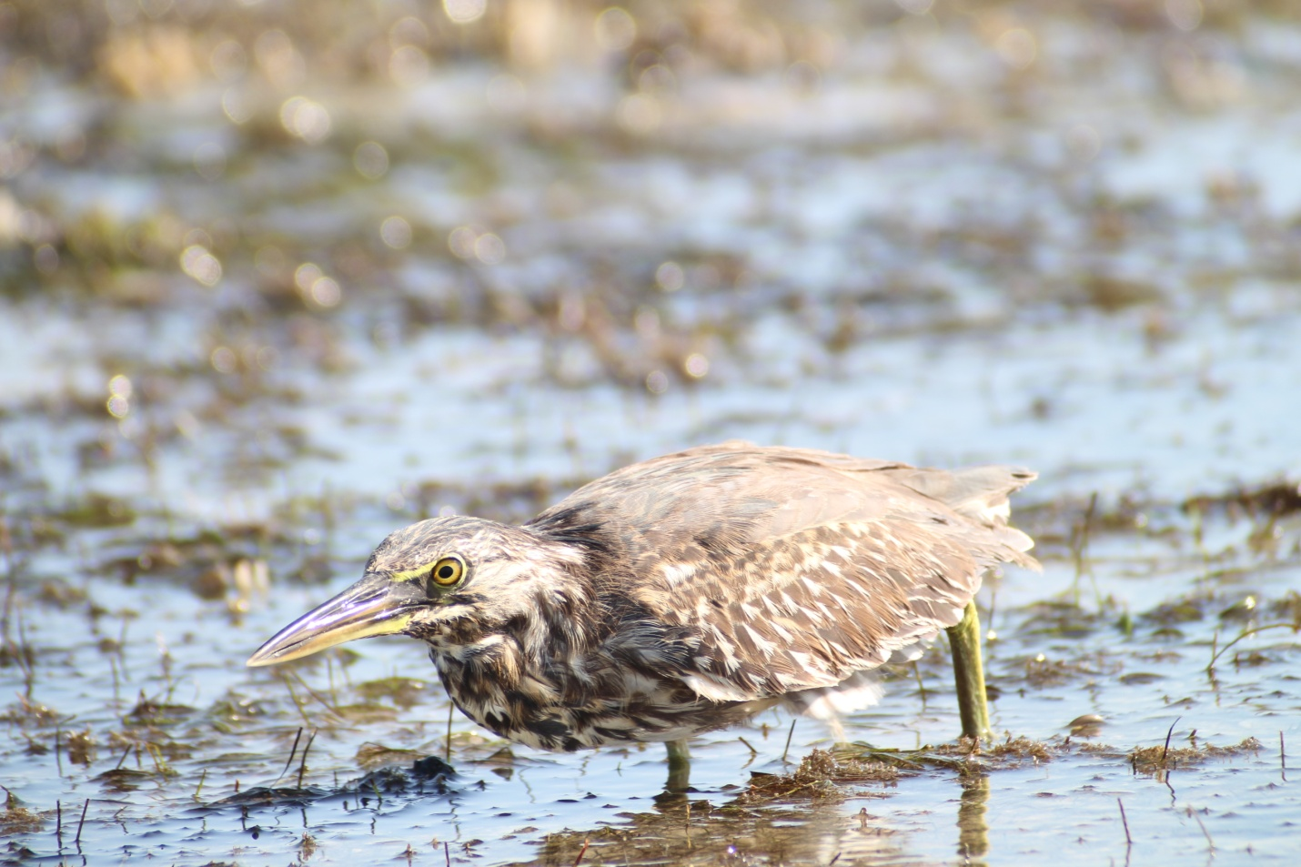
Bodó Attila : Striated Heron-Butorides striata, Barr al Hikman
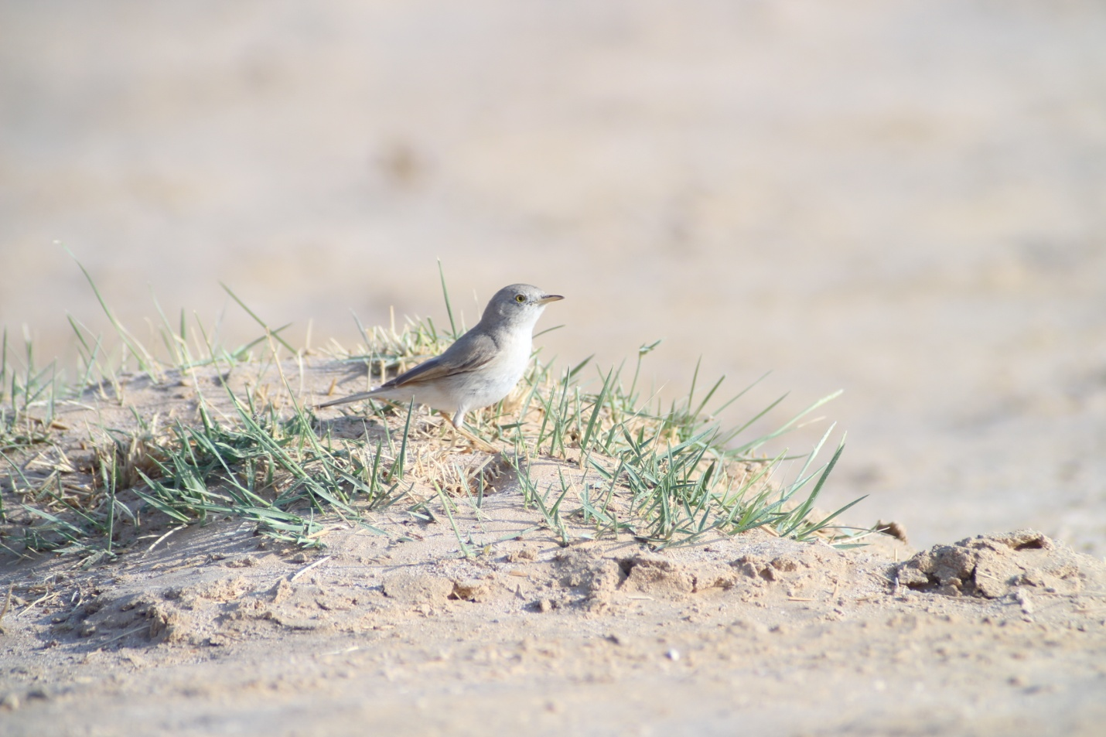
Bodó Attila: Asian Desert Warbler-Sylvia nana, oaza Muntasar
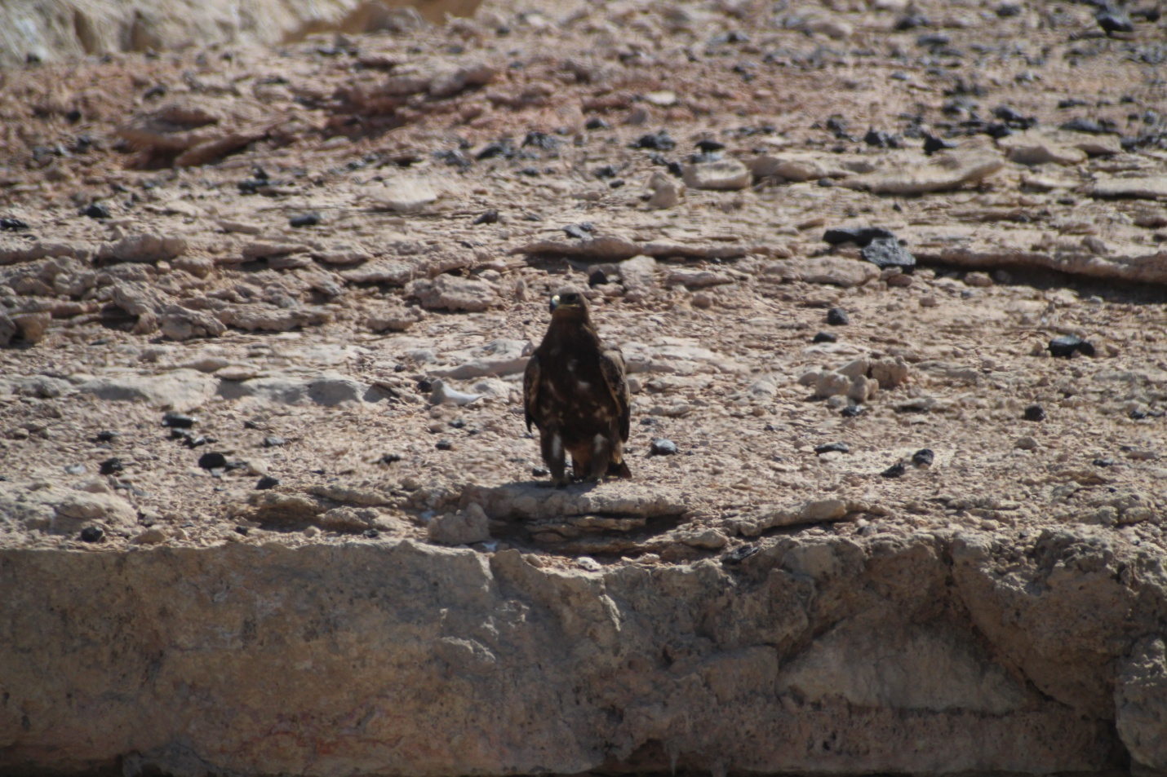
Bodó Attila: Aquila nipalensis, rampa de gunoi Thumrait
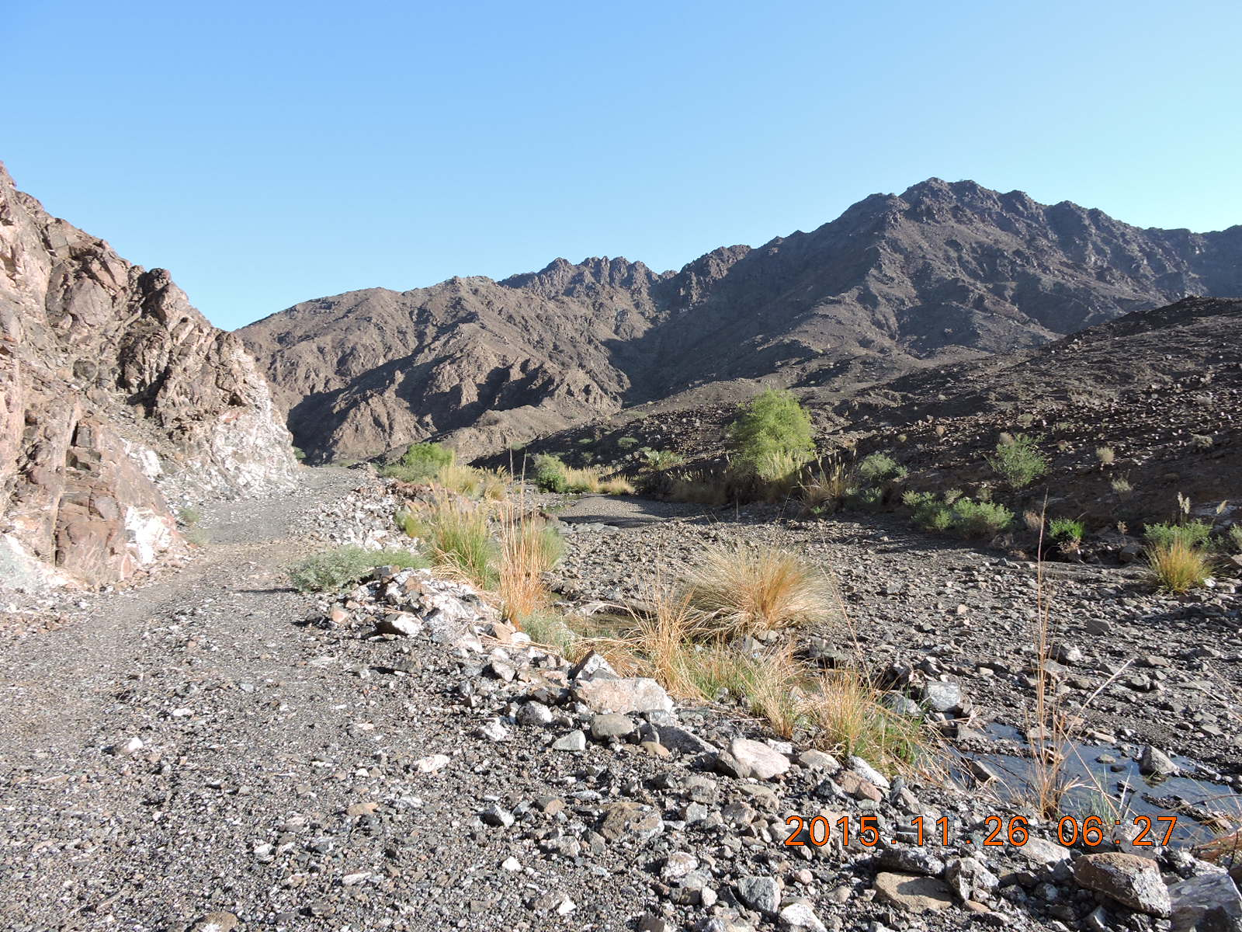
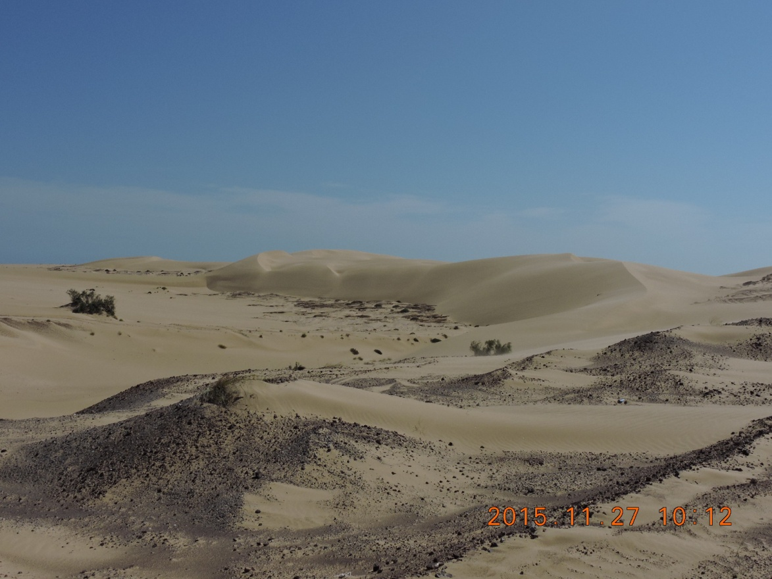
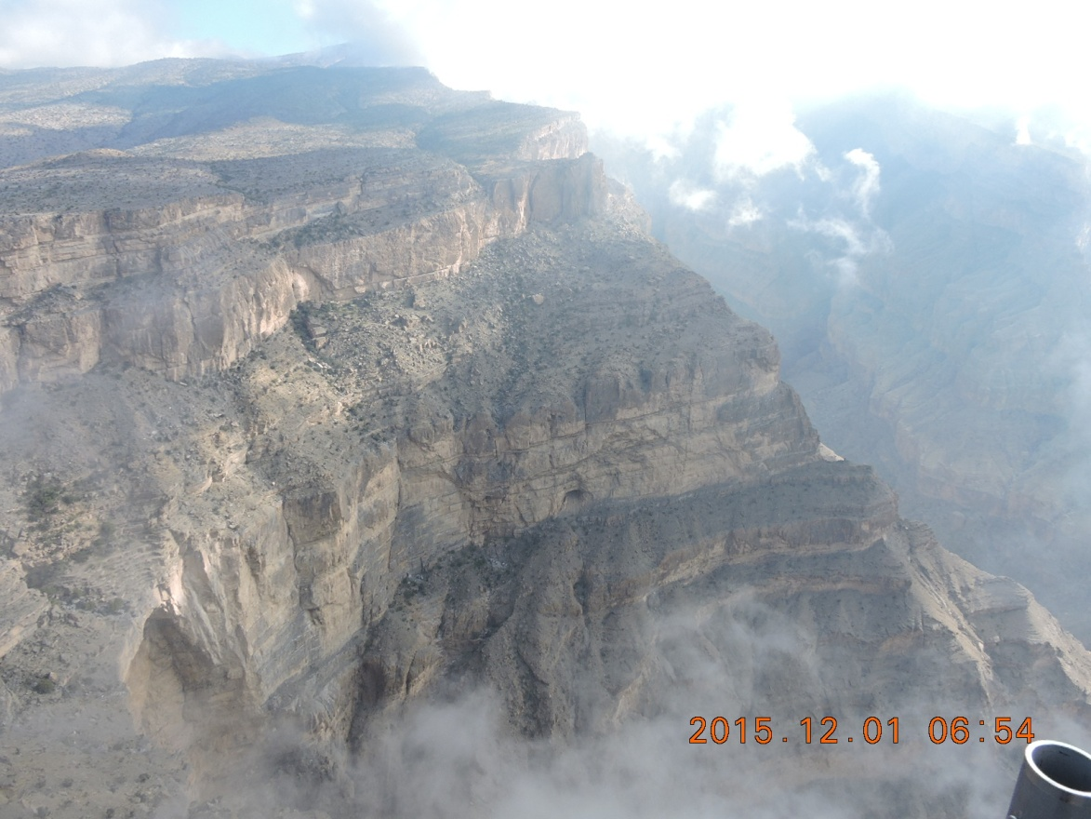

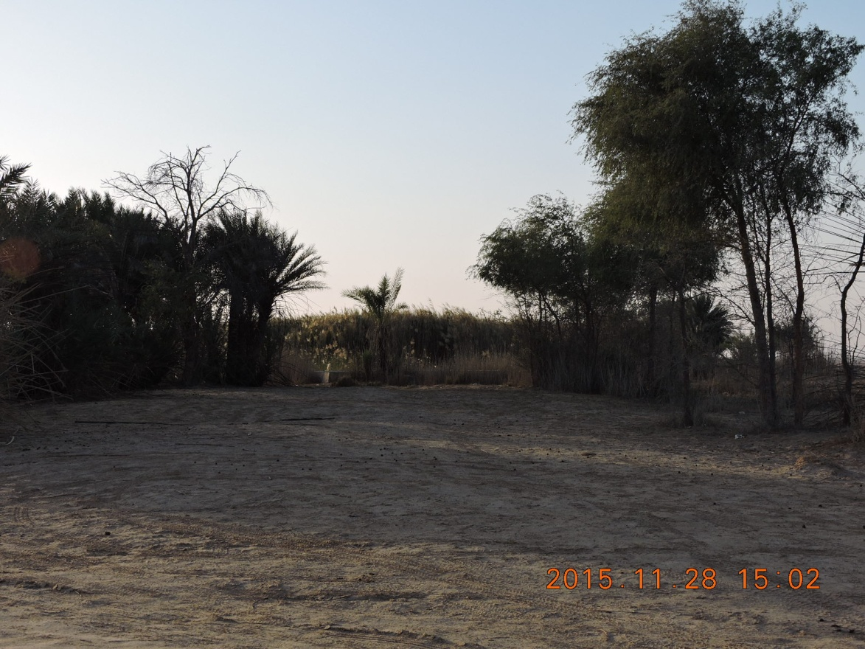
Oaza Muntasar

